**DAILY ONLINE ACTIVITIES SUMMARY**

|  |  |  |  |
| --- | --- | --- | --- |
| **Date:** | 11/07/2020 | **Name:** | Krishnitha |
| **Sem & Sec** | 4th sem, A Section | **USN:** | 4AL18CS039 |
| **Online Test Summary** | | | |
| **Subject** | NA | | |
| **Max. Marks** | NA | **Score** | NA |
| **Certification Course Summary** | | | |
| **Course** | Salesforce Mobile App Customization | | |
| **Certificate Provider** | Sales force | **Duration:** | 3 hrs |
| **Coding Challenges** | | | |
| **Problem Statement:**  Write a Java program for Reversal algorithm for array rotation by 3. | | | |
| **Status:** Executed | | | |
| **Uploaded the report in GitHub** | | YES | |
| **If yes Repository name** | | <https://github.com/krishnitha/Java-coding> | |
| **Uploaded the report in slack** | | YES | |

**Certification Course Details:**

Today I started the new course “Salesforce Mobile App Customization” by Sales Force. Today I learnt about how to Create Global Quick Actions and to Create Object-Specific Quick Actions.

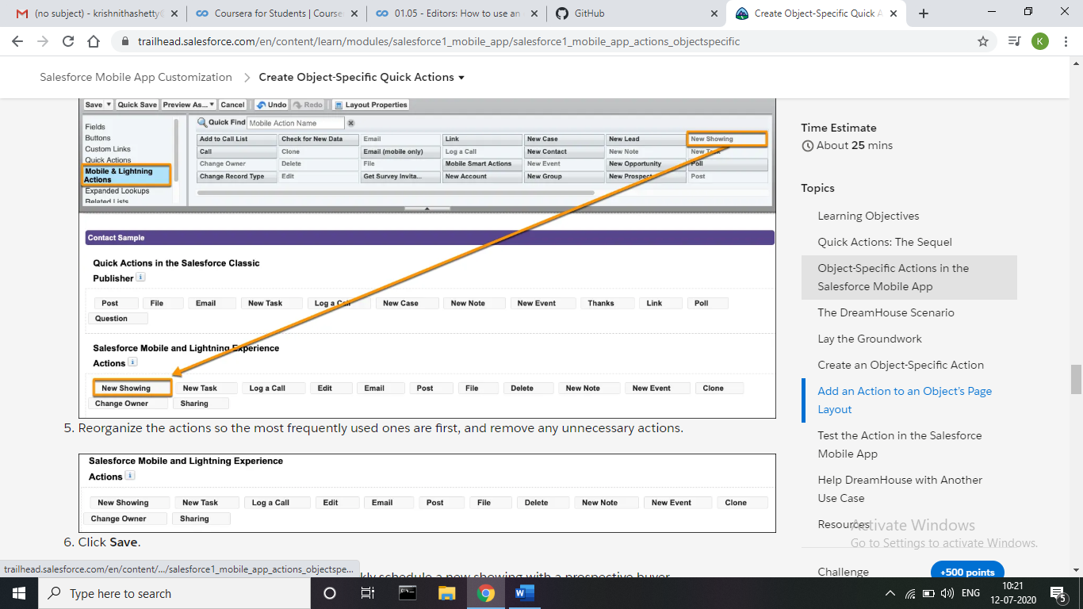

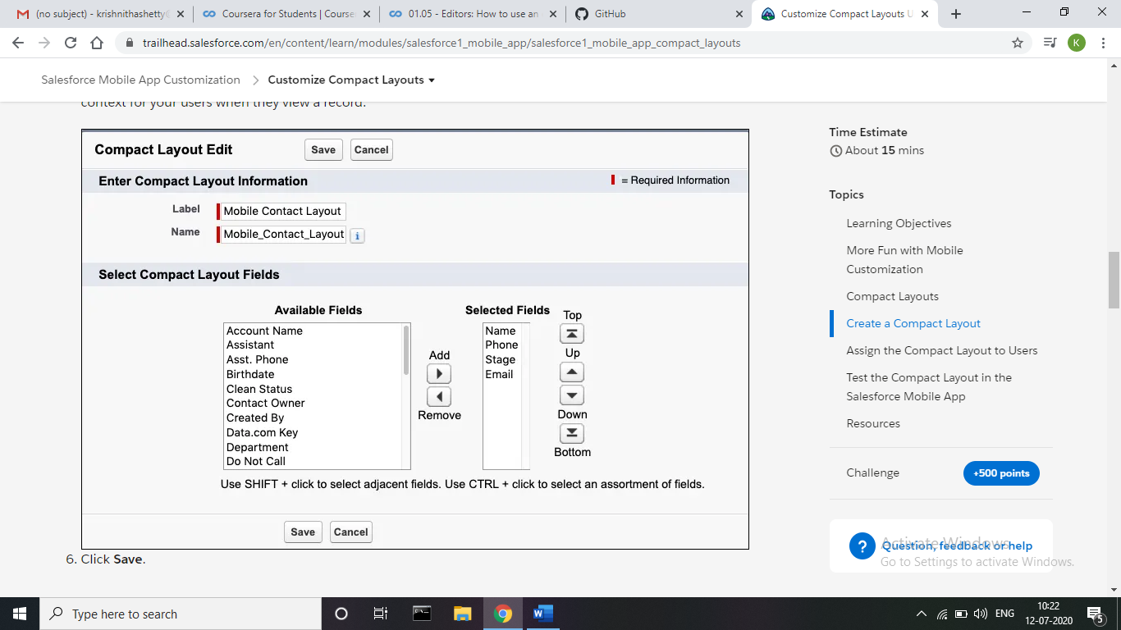

**Coding Challenges Details:**

**Problem:** Write a Java program for Reversal algorithm for array rotation by 3.

Given an array a[], array size n and d the number of index to be rotated task is to write a function rotate(arr[],d,n) that rotates arr[] of size n by d elements.

**Example**  
Input:  
n= 6  
arr[]= {1,2,3,4,5,6}  
d=3 (specific)  
Output: arr[]= {4,5,6,1,2,3}

**Solution:** Uploaded it in GitHub

